1. a) Find the value of R in the circuit of fig.

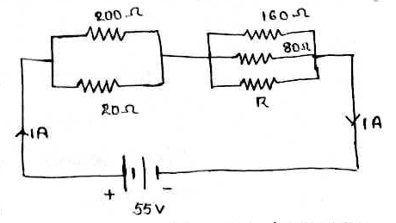

b) Find the single equivalent resistance between A and B in the circuit of fig by

network reduction.

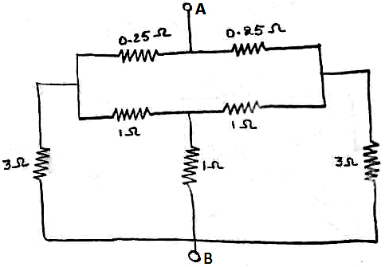

1. For the network shown in fig. develop the fundamental cut set matrix and write KCL equations.

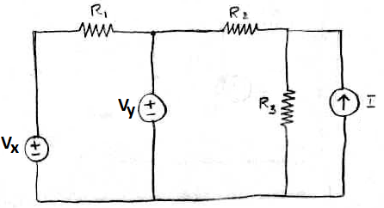

1. Find the magnitude of currents in 10Ω resistor in the network by mesh analysis.

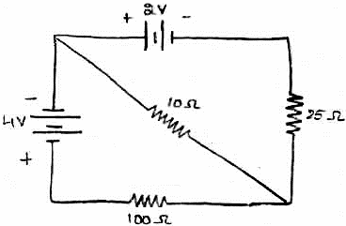

1. Find the current through 4Ω resistor in the circuit of figure by nodal method.

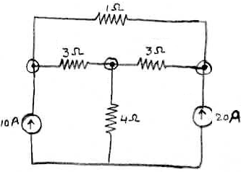

1. A RLC series circuit has a resistance of 100  , Inductance 0.5H and the maximum current flows through it at a frequency of 40Hz. If the supply is 100V at 50 Hz, find the current, power factor and voltage across each element.
2. Draw the the phasor diagram for a pure resistor, inductor, capacitor, R-L series circuit, R-C series circuit.